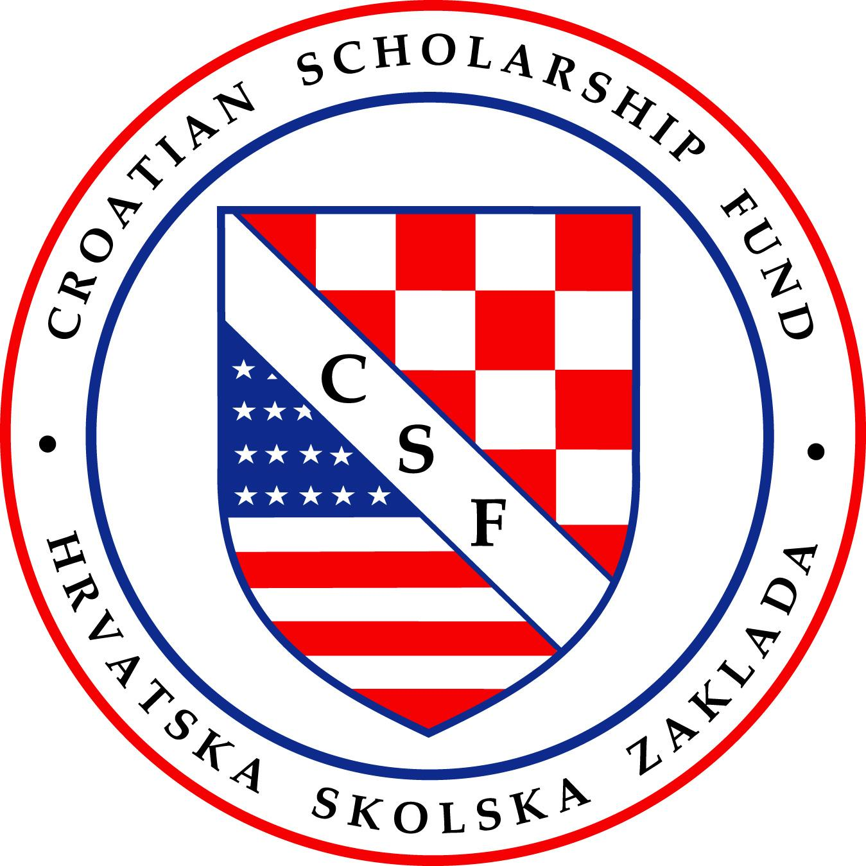
Sponsor Designated Form for Croatian Scholarship Fund
P.O. 290, San Ramon, CA 94583 • www.croatianscholarship.org • 530 392 2467
Yes! I want to help support CSF’s efforts to provide scholarships to university students in Croatia and Bosnia-Hercegovina. Thank you for your Support!
Sponsor Name: _________________________________________________________________________
Address: _______________________________________________________________________________
City: ________________________________________________State: _______ ZIP: __________________
Phone: (________) __________- ____________Email: _________________________________________ May we share your address and email with your student Yes_____ No ____
This sponsorship is designated for the following (mark one):
☐ Full Scholarship, sponsorship for 1 year, $2,000.00
☐ Full Scholarship, sponsorship for 3 years, $6,000.00 –Funds undergraduate study, annual payments are acceptable.
☐ Full Scholarship, sponsorship for 5 years, $10,000 – Funds undergraduate and masters study Note: Students at Croatian universities can earn a bachelor’s degree in three years and a master’s degree in two additional years. Students in CSF Program receive scholarship for up to 5 years. Majority of sponsors provide financial assistance to students for three years of undergraduate work at $ 2,000/ per year. Many sponsors also elect to fund two additional years of student’s master’s degree study at $2,000 per year. Payments can be made in full or annually. Over 95% of CSF students continue to earn a master’s degree.
Please specify below if you have a Special Request: Scholaraship in memory of, a student from specific region in Croatia, specific major and or university, etc.) ______________________________________________________________________________________
Payment options:
- Payment can be sent electronically. Most US banks utilize ZELLE funds transfer service. Unlike credit card payment no fees are charged to use ZELLE. Use our email address info@croatianscholarship.org as a recipient name.
- Mail the check to Croatian Scholarship Fund, P.O. 290, San Ramon, CA 94583
- Charge my Credit Card, information can be called in to CSF -Marijana Pavic 530 392 2467
Please mark payment type and the amount:
☐ Electronic Payment ☐ Mail in check ☐ Credit Card Payment Amount $________________________
Please complete, sign and mail in or email this form at info@croatianscholarship.org
The Croatian Scholarship fund is a non-profit (501)(c) (3) organization registered with the Internal Revenue Service (Federal Tax ID number 68-0231056). Please consult with your tax advisor concerning the deductibility of your donation.

Sponsor Signature: _______________________________________________Date: ___________________

